Sebastián Rojas

Pablo Blanco

Diego Velazquez

**Herramientas básicas - Actividad 1.1**

**1.1 In the area of Fig 1.4,**

1. Which vertices are leaves and which are interior vertices?
2. Which vertices are the sons of 5?
3. Which vertex is the father of 5?
4. What is the length of the path from 1 to 9?
5. Which vertex is the root?

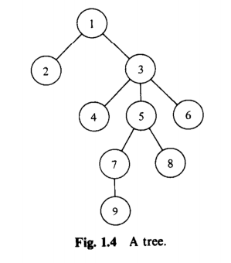

**1.2 Prove by induction on n that**

